First steps

MX-Fluxbox RaspberryPi Community Respin

Configuration 1
Sound 3
Bluetooth 5
Wifi 5

Once you have booted your new installation, connected to a network, and watched the introductory video, there are a few things you may want to configure. This brief guide will help you.

Configuration

Raspberry Pi
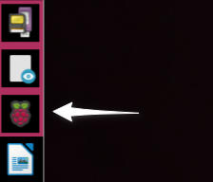
On the Dock, click the Raspberry icon to open the configuration window:

On the first tab, you can change from the default password. It is common sense to do this. You need to enter the new password twice, to check it has been entered correctly. Please make sure you remember it!
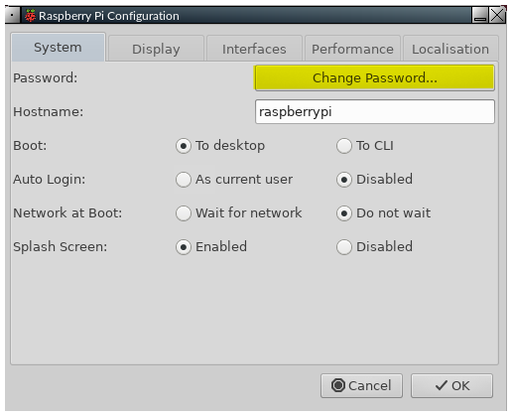

The Raspberry Pi was designed with the ability to work with a TV as the display. When used with a monitor, you may see a black border around the outside of the window. In this case, you need to enable Underscan. Select the Display tab, and click the Disable bullet button:

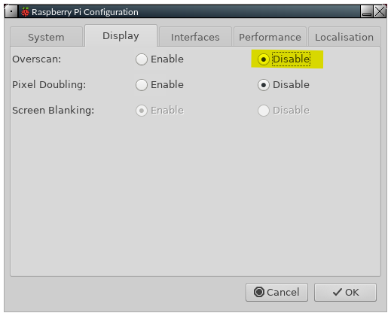

Finally, you need to set up various things to suit the country you are in, the timezone, and the keyboard layout you are using. Select the Localisation tab, then set each item as needed. Allow each setting to be saved after you have made it:

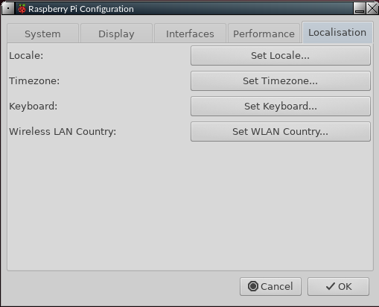

When you have made all the necessary changes, click OK. You will be prompted to allow a reboot, which you should do. When you get back to the login page, remember to use your new password!

You can now begin to enjoy the slick, fast new operating system you have.

Window manager
Right-click the desktop > Appearance or Settings. Details in the Fluxbox FAQ document: press F1 or click the dock icon with a question mark.

Desktop icons
Right-click the desktop > Appearance > Desktop icons, which brings up iDesktool. Details in the Fluxbox FAQ document: press F1 or click the dock icon with a question mark.

Dock
Right-click the desktop > Appearance > Dock, which brings up Dockmaker. Details in the Fluxbox FAQ document: press F1 or click the dock icon with a question mark.

Traditional panel
Click the icon next to the MX start button. Brings up the graphic configuration app for the panel (tint2).

Sound

Sometimes, sound will not be heard at first from your TV or monitor. There are a number of things to try to correct this.

1) Firstly, both the Pi 4 and Pi 400 have two micro-HDMI output ports. The port on the Pi 4 that is nearest the power input connector is the master. The port on the Pi 400 that is farthest from the power input connector is the master. In both cases, the master connector is the left port of the two.
When using a single display, you should always use the master. If that is not the case, shut your Pi down, power it off, swap the HDMI cable to the master port, reboot, and see if sound now works.
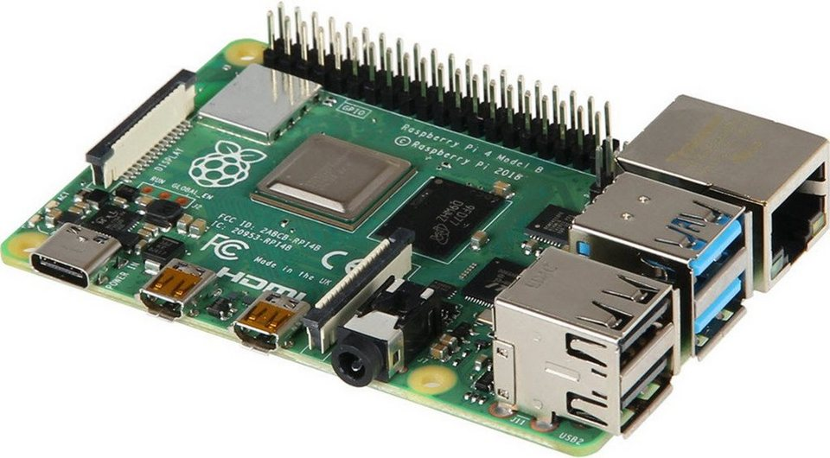

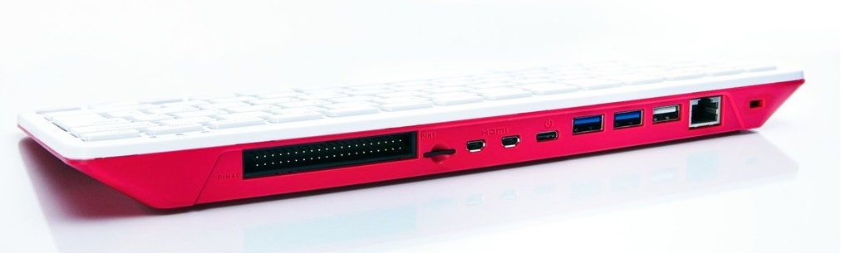

2) If unsuccessful, the next thing to try is the Raspberry Pi's advanced configuration settings. The settings tool cannot be used with a mouse, so you need to use the arrow and tab keys to move around.

To access this, open a terminal and enter:

sudo raspi-config

- Option 1, System Options, will be highlighted. Press Enter once.

- You will see that option S2 is for Audio configuration, so press the down arrow once, then press Enter.

- The highlighted entry will be 0 HDMI 1, and that is what is needed. Press the Tab key once, so OK is highlighted, then press Enter.

- You will be returned to the first screen. Press the Tab key twice, so that Finish is selected, then press Enter.

- You should now find that sound works OK. There is no need to reboot.

If this does not fix things, there is a lot of helpful information here:

https://www.raspberrypi.org/documentation/configuration/config-txt/video.md

Bluetooth
Bluetooth (=BT) devices work with the MX Fluxbox Rasperry Pi respin. For the Pi 4 and Pi 400, the good news is that the Debian app Blueman now works, having been previously reported to crash the system for Pi 3s. It has been set up so that its functions can be accessed by clicking the familiar BT icon in the system tray.
- Mouse. A BT mouse normally works without need for the user’s involvement.
- Keyboard. Log in the first time with a wired keyboard or use the on-screen keyboard “onboard” (click on the little human figure at the right end of the top bar). Make sure that the keyboard is turned on. Click the BT icon > Devices, and then click the “Scan” on the screen that pops up. When the keyboard appears on the list, right-click it > Setup.
Do not Pair yet!
Instead, select “Proceed without Pairing” so that the keyboard will work. Then use Setup again > Pair, and enter the code that is displayed in the message box. If the code entry does not work, use the MX menu to launch the on-screen keyboard for input.
The keyboard will normally reconnect when logging out and back in, but may not reconnect with a reboot. You can again click on the little human figure at the right end of the top bar of the login screen to see the on-screen keyboard. Once logged in, enable the keyboard again by clicking the BT icon > Recent Connections > Human Interface etc.
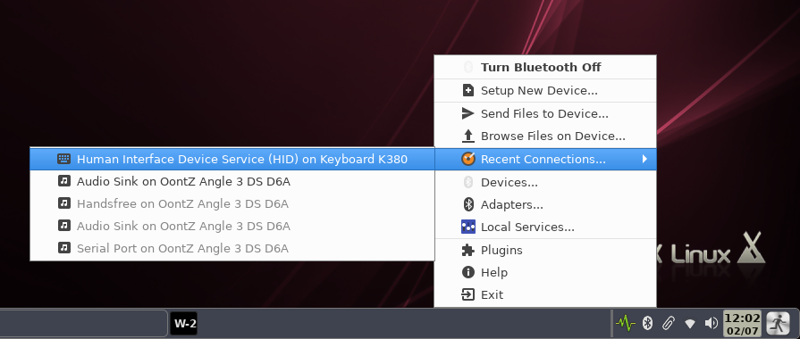

If the keyboard is not visible when attempting to pair is not visible then the device file may become corrupted. In such a case, right-click the entry in the device screen > Remove. Then log out and back in and repeat the procedure described above for a new device.
- Speakers/Headphones. The desktop has been configured so that such a device is linked to Pulse Audio for mixer, and a blockage that normally interferes has been evaded by restarting the linkage every time the user logs in using a script in ~/.fluxbox/scripts named “BTheadphones_reset." Follow the setup process, making sure that the device is connected to the Audio Sink. It will normally reconnect upon login but, if it does not, click the BT logo in the system tray > Recent Connections > Audio Sink etc.
If you want to remove the BT icon from the system tray, open theFluxbox “startup” file by right-clicking the desktop > Settings > Configure > Main Config > Startup, search for “blueman-applet” and comment out the line like this:
#blueman-applet &

Wifi

Click the wifi icon in the system tray and select the access point you want. If you run into problems, consult the Ubuntu community documentation.

